**National University of Computer and Emerging Sciences** Operating System Lab - 09

*Lab Manual*

Contents

Objective 2

Kernel Modules 2

Why We Need Kernel Modules? 2

List of Currently Loaded Modules 2

Command to Insert or Remove Modules 2

Writing Kernel Modules 3

Writing Your First Module and Insert it to the Kernel 3

With module_init() & module_exit() i.e. Init Macros 5

With Licensing and Documentation 5

printk() 7

Module Parameters 7

Modifying Parameter Value 9

Implementation of Kernel Threads 10

Lab Task: 11

# Objective

The objective of this lab is to demonstrate how to compile, load, list and remove modules from/to kernel and introduce module parameters i.e. how to add parameter in you module, adding parameter to your modules, types of parameter and setting parameter from outside kernel module. To introduce kernel symbol table and /proc file system.

# Kernel Modules

*“Modules are pieces of code that can be loaded and unloaded into the kernel upon demand.”*

Linux kernel modules are shared object files with extension ‘.o’ (for kernel version 2.4 or lower) or ‘.ko’ (for new kernel version). They are chunk of kernel code and they compiled separately. They can be removed or inserted at any time. They extend the functionality of the kernel without the need to reboot the system. For example, one type of module is the device driver, which allows the kernel to access hardware connected to the system.

# Why We Need Kernel Modules?

Without modules, we would have to build monolithic kernels and add new functionality directly into the kernel image. Besides having larger kernels, this has the disadvantage of requiring us to rebuild and reboot the kernel every time we want new functionality. So modules there are various advantages of modules but the most common attraction of creating modules is that it saves kernel image size and it also save RAM and disk storage.

# List of Currently Loaded Modules

There are two ways in which you can list currently loaded modules. These are as follow

* View the contents of ‘/proc/modules’ file using cat
* Run ‘lsmod’ command

Both of the above ways tell you which modules are currently loaded. However, the output format of both is different. ‘lsmod’ command will print loaded modules in long list format and ‘cat /proc/modules’ would list all the loaded modules but readable format is not guaranteed.

# Command to Insert or Remove Modules

|  |  |  |
| --- | --- | --- |
| **Command** | **Description** | **Example** |
| **insmod** | Inserts module in kernel | insmod <module_name>.ko |
| **rmmod** | Removes module from kernel | rmmod <module_name> |

**Let’s Google:**

**mod probe** does the similar work like insmod. What is the difference between two??

# Writing Kernel Modules

## Writing Your First Module and Insert it to the Kernel

Before we begin, lets first go come back as a root user as we will work inside kernel mode and normal users are not permitted to play with it! Type the below commands to create directories and files.

~/$ sudo -i

~/$ mkdir /hello

~/$ cd /hello

/hello$ touch hello.c ; touch Makefile

Now that are directory and files are created, we need to put content in it.

Copy this content into the ‘hello.c’ file

|  |
| --- |
| #include <linux/module.h> /* Needed by all modules */ #include <linux/kernel.h> /* Needed for KERN_INFO */  int init_module(void) {  printk(KERN_INFO "hello [INFO] Hellow World! \n");  /*  * A non 0 return means init_module failed; module can't be loaded.  */  return 0;  }  void cleanup_module(void) {  printk(KERN_INFO " hello [INFO] Goodbye World! \n ");  } |

**Points to Ponder:**

Kernel modules must have at least two functions:

* "start" (initialization) function called init_module() which is called when the module is insmoded into the kernel
* "end" (cleanup) function called cleanup_module() which is called just before it is rmmoded.

Typically, init_module() either registers a handler for something with the kernel, or it replaces one of the kernel functions with its own code (usually code to do something and then call the original function). The cleanup_module() function is supposed to undo whatever init_module() did, so the module can be unloaded safely.

Now copy the below content to ‘Makefile’

|  |
| --- |
| obj-m += hello.o  all:  make -C /lib/modules/$(shell uname -r)/build M=$(PWD) modules  clean:  make -C /lib/modules/$(shell uname -r)/build M=$(PWD) clean |

Once the file is created we need to compile it. To compile the code we use the make command. /hello$ make

If it compiled successfully you would get the following output.

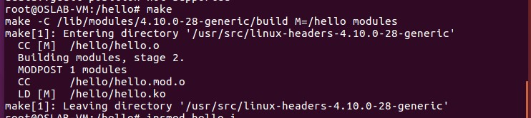

Now we insert the compiled module to the kernel module’s list so that it starts executing

/hello$ insmod ./hello.ko

To verify that our module is added to the list, we can do this by using the following command

/hello$ lsmod | grep hello

This should give the following output



To see that the output from our module run ‘dmesg | tail -1’

*“dmesg - print or control the kernel ring buffer”*



You can see that init_module function is called however, cleanup_module is called when you remove your module, hence init_module function will setup the module which may call a function that will run forever in a while loop and cleanup_module is called to terminate that function and to stop the execution of the module. To remove the module from the list, use the following command.

/hello$ rmmod hello

/hello$ dmesg | tail -2

This should generate the following output

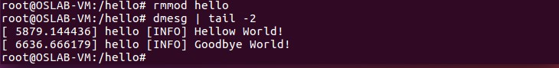

## With module_init() & module_exit() i.e. Init Macros

As of Linux 2.4, you can rename the init and cleanup functions of your modules; they no longer have to be called init_module() and cleanup_module() respectively. This is done with the module_init() and module_exit() macros. These macros are defined in linux/init.h. The only caveat is that your init and cleanup functions must be defined before calling the macros, otherwise you'll get compilation errors. Here's an example of this technique: The below file was tested and compiled with name hello-2.c

|  |
| --- |
| /*  * hello-2.c - Demonstrating the module_init() and module_exit() macros. * This is preferred over using init_module() and cleanup_module().  */  #include <linux/module.h> /* Needed by all modules */  #include <linux/kernel.h> /* Needed for KERN_INFO */  #include <linux/init.h> /* Needed for the macros */    static int __init hello_2_init(void) {  printk(KERN_INFO "hello-2 [INFO] Hellow World \n");  return 0;  }    static void __exit hello_2_exit(void) {  printk(KERN_INFO " hello-2 [INFO] Goodbye World \n ");  }    module_init(hello_2_init); module_exit(hello_2_exit); |

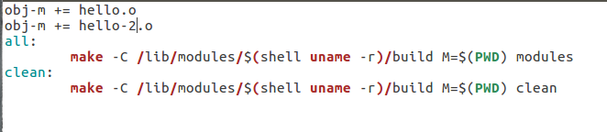

## With Licensing and Documentation



In kernel 2.4 and later, a mechanism was devised to identify code licensed under the GPL so people can be warned that the code is non open-source. This is accomplished by the MODULE_LICENSE() macro. By setting the license to GPL, you can keep the warning from being printed. This license mechanism is defined and documented in ‘linux/module.h.

* MODULE_DESCRIPTION() is used to describe what the module does
* MODULE_AUTHOR() declares the module's author
* MODULE_SUPPORTED_DEVICE() declares what types of devices the module supports.

These macros are all defined in linux/module.h and aren't used by the kernel itself. They're simply for documentation and can be viewed by a tool like objdump.

The following code demonstrate licensing and documentation of code.

|  |
| --- |
| #include <linux/module.h> /* Needed by all modules */  #include <linux/kernel.h> /* Needed for KERN_INFO */  #include <linux/init.h> /* Needed for the macros */  #define DRIVER_AUTHOR "Sumaiyah Zahid <www.sumaiyahzahid.com>"  #define DRIVER_DESC "A sample module code to demonstrate licensing and documentation."    static int __init init_hello_3(void) {  printk(KERN_INFO " hello-3 [INFO] Hellow World \n "); return 0;  }  static void __exit cleanup_hello_3(void)  {  printk(KERN_INFO " hello-3 [INFO] Goodbye World \n ");  }  module_init(init_hello_3);  module_exit(cleanup_hello_3);    /*  Get rid of taint message by declaring code as GPL.  */  MODULE_LICENSE("GPL");  /*  Or with defines, like this:  */  MODULE_AUTHOR(DRIVER_AUTHOR); /* Who wrote this module? */  MODULE_DESCRIPTION(DRIVER_DESC); /* What does this module do */    /*  This module uses /dev/testdevice. The MODULE_SUPPORTED_DEVICE macro might be used in the future to help automatic configuration of modules, but is currently unused other than for documentation purposes.  */  MODULE_SUPPORTED_DEVICE("testdevice"); |

The above code is written on a file name ‘hello-3.c’ and the Makefile modified as previous.

Now compile and run the following command

/hello$ modinfo hello-3.ko

The above command would get the following output

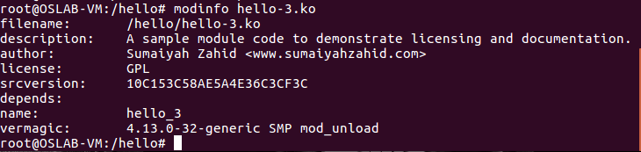

# printk()

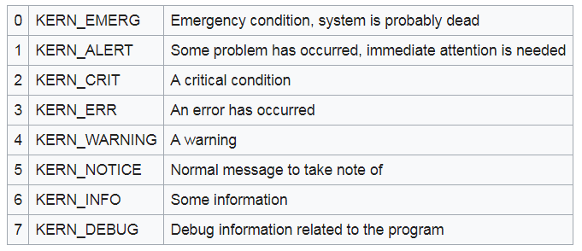

# Module Parameters

Previously, we studied modules without parameters that have a static output and no user or time interaction. These modules are no good since they have a very limited functionality. Modules are just like functions that need parameters i.e. user input to produce variation in their outputs.

Addition of variables to a module is a bit tricky, since now we are working in kernel space and we don’t have access to the screen so there is no direct way to get user inputs for our modules. What we do is to make our parameters static so that they could stand outside the module, and we could address them from there.

Well, there are three types of symbols according to their visibility scope:

1. STATIC: visible only in their source file
2. EXTERNAL: visible only for built – in kernel source code
3. EXPORTED: visible for apparently all loadable kernel modules

After addition of some parameters your module code looks like the following:

|  |
| --- |
| #include <linux/module.h>  #include <linux/init.h>  #include <linux/kernel.h>  #include <linux/jiffies.h>    static int answer = 42;  int mod7_external_param =91;  int mod7_exported_param = 73;    static int __init mod7_in(void)  {  printk(KERN_INFO "module mod5 being loaded. \n"); printk(KERN_INFO "Current jiffies are: %lu. \n",jiffies); printk("Initial value for answer is %d. \n", answer); return 0;  }  static void __exit mod7_out(void)  {  printk(KERN_INFO "final value for answer is %d. \n",answer); printk(KERN_INFO "module mod5 being unloaded. \n");  }  module_init(mod7_in);  module_exit(mod7_out);    //module_param(answer, int, 0644);  module_param_named(mod7_intparam, answer, int, 65); MODULE_PARM_DESC(answer, "testing module parameters");    EXPORT_SYMBOL(mod7_exported_param);    MODULE_AUTHOR("ABC");  MODULE_LICENSE("GPL");  MODULE_DESCRIPTION("symbols exported and otherwise..."); |

One more thing that although sounds a bit weird about the modules is that by themselves, modules never know that they have any parameter, so they don’t expect any output from outside the module that is command line. So you need to explicitly tell a module that it does have a parameter named this, and of type this with these user rights outside you (module). You can do this by:

module_param(variable_name, variable_type, user_rights)

as written in comments in above code. The user rights have the octal value representing owner, group and others, prefixed by a zero. The reason that the line is commented out is that the very next line to code does exactly the same job with an extension.

If you know that your variable will be listed and used among those thousands of kernel’s variables, you need to use some way to make it look unique in the list for the sake of identification. So preferably you would use something like myMod_var_int to make it stand out of the crowd, sounds good, but… using this long name for a variable that is redundant in your code may lead to frequent mistakes in writing the variable name, resulting in long list of errors when you would run “make”. The solution to this is, there should be some way that you could use a smaller alias of the variable name in module during programming and use a longer more expressive or descriptive name for addressing it from outside, this is exactly what module_param_named does. It renames the variable to a new name that is visible to outside world letting you use your short less descriptive name inside. The syntax is similar except for that the list of parameters to this function also includes the new name of the variable.

module_param_named(new_variable_name, old_variable_name, variable_type, user_rights)

There are two exported kernel symbols that we are using in our module. First one is jiffies which is defined in jiffies.h representing cpu instruction logical timer value, and the other is the function printk() which we are using for output in log file.

Remember two things can be exported, variables and functions and these are jointly referred to as symbols in Kernel programming terms.

# Modifying Parameter Value

The value of these parameters can be set by any of the three ways:

1. **Set a value by default during writing your program**

This is the simplest and least flexible method among the three that is you initialize variables at the time you declare them. This value is constant and persists till end if neither changed by program itself nor modified from outside.

1. **Set a value at the time of module insertion**

In this method you simply write the assignment statement right after insmod module_name.ko as shown in following

insmod Lab9M1.ko my_param=93

1. **Set a value during execution of module**

There is a system directory that keeps records of all running modules along with their parameters. If allowed in user rights, you can modify it from there using echo command like below:

echo 27 > /sys/module/Lab9M1/parameters/mod7_intparam

# Implementation of Kernel Threads

It is often useful for the kernel to perform some operations in the background. The kernel accomplishes this via kernel threads—standard processes that exist solely in kernel-space. Indeed, a kernel thread can be created only by another kernel thread.

#include<linux/module.h>

#include<linux/kernel.h>

#include<linux/kthread.h>

#include<linux/sched.h>

#include<linux/time.h>

#include<linux/timer.h>

static struct task_struct *thread1;

int a=21;

int threadFnc(void *t){

int i = 1;

int x=*(int *)t;

for(i = 1; i <= 10; i++)

{

printk(KERN_INFO "%d X %d = %d\n", i,x,x*i);

printk(KERN_INFO "");

}

do_exit(0);

return 0;

}

int thread_init(void) {

char our_thread[8]="thread1";

printk(KERN_INFO "in init");

thread1 = kthread_create(threadFnc,&a,our_thread);

if((thread1)) {

printk(KERN_INFO "in if");

wake_up_process(thread1);

}

return 0;

}

void threadCleanup(void) {

printk(KERN_INFO "cleaning up kthread");

printk(KERN_INFO "");

kthread_stop(thread1);

}

MODULE_LICENSE("GPL");

module_init(thread_init);

module_exit(threadCleanup);

# Lab Task:

* Implement all the above codes and submit screenshots of Kernel messages.
* Implement Kthread for printing 5 tables.